On

ve

Project manual
A handbook to managing projects in the European Scientific Advisory Board on Climate Change



Table of content

Table of content 2
1. Introduction 4
2. Overview of guidelines, reference documents and templates in the different phases of the project 5
3. Inception phase 7
3.1 Purpose of the inception phase 7
3.2 Key activities in the inception phase 7
3.3 Key deliverables in the inception phase 7
3.4 Requirements for a change in phase 7
3.5 Roles and responsibilities in the inception phase 8
3.6 Key questions – in connection to the project description 9
3.7 The project proposal 9
3.8 Discussion at Advisory Board meetings 9
4. Scoping phase 12
4.1 Purpose of the scoping phase 12
4.2 Key activities in the scoping phase 12
4.3 Key deliverables in the scoping phase 13
4.4 Requirements for a change in phase 13
4.5 The kick-off meetings 13
4.7 Narrative of the report 16
4.8 The outline of the report 18
4.9 Stakeholder engagement – Mapping, prioritising, and involvement of key stakeholders 18
4.10 Risk analysis 21
4.11 The planning of the project 22
4.12 Step-by-step approach to the scoping phase 24
5. Analysis and drafting phase 27
5.1 Purpose of the analysis and drafting phase 27
5.2 Key activities in the analysis and drafting phase 27
5.3 Key deliverables in the analysis and drafting phase 27
5.4 Requirements for a change in phase 27
5.5 Roles and responsibilities in the analysis and drafting phase 28
5.6 Key questions – which the project team is expected to consider 29
5.7 Evolution of the draft 31
5.8 Strategic review 35
5.9 Developing the communication plan 36
6. Production and outreach phase 38
6.1 Purpose of the production- and outreach phase 38
6.2 Key activities in the production- and outreach phase 38
6.3 Key deliverables in the production- and outreach phase 38
6.4 Requirements for a change in phase 38
6.5 Roles and responsibilities in the production- and outreach phase 39
6.6 Key questions – which the project team is expected to consider 40
6.7 Production 40
6.8 Publication 41
7. Evaluation 44
7.1 Purpose of the evaluation phase 44
7.2 Key activities in the evaluation phase 44
7.3 Key Deliverables in the evaluation phase 44
7.4 Requirements for a change in phase 44
7.5 Roles and responsibilities in the evaluation phase 44
7.6 Key questions – which the project team is expected to consider 45
7.7 Project evaluation in the Secretariat (Evaluation Matrix) 45
7.8 Project evaluation in the Advisory Board (Evaluation Matrix) 47

Introduction

This project manual is a key element of the project framework that describes the process for each project undertaken by the European Scientific Advisory Board on Climate Change.

In this project manual, you will find a detailed description of activities, guidelines and an overview of the tools and templates for the different phases.

The project manual serves as a handbook for each project team within the Secretariat and outlines the guidelines and the tools that can be supportive during the process. The project manual also explains the step-by-step approach and provides best practice examples for each phase.

The entire project framework consists of three layers:

- Project framework overview: provides an overview of the project lifecycle, the workflow and phases, and describes the project organisation and the roles and responsibilities of those involved in the project
- Project manual: explains in detail the different activities in each phase and provides guidelines as well as an overview of available tools and templates that can be useful when carrying out a project.
- Tools and templates: provides a standard way of managing and presenting different project elements as well as templates for the draft report.

In addition to the project framework, the Advisory Board has a number of policies and documents that can be consulted as part of the project:

- The Advisory Boards visual identity: outlines the overarching design principles of how the Advisory Boards presents itself and its different outputs.
- The Advisory Board publishing guide: describes all stages of editing, layout, print, web publishing and dissemination via CRMS.
- EEA writing guide: explains conventions and preferred spellings and gives guidance on how to write clearly in relation to EEA products. Can also be used as a reference for Advisory Board outputs.

Overview of guidelines, reference documents and templates in the different phases of the project
The following chart shows an overview of relevant guidelines, reference documents and templates for each of the phases in the project. The guidelines, reference documents and templates appear in the phase where they are used for the first time.

The complete overview of the entire project framework, outlining the workflow and phases and the roles and responsibilities, can be found in separate document.

- Evaluation in the
Secretariat
- Evaluation in the
Advisory Board
- Production
- Publication
- Narrative
- Strategic perspectives
- Evolution of the draft
- Communication plan
- Project proposal
- Discussion in
Advisory Board
meetings

- Project description
- Kick-off meeting
- Milestone plan
- Stakeholder engagement
- Risk analysis

GUIDELINES

- Project description, narrative and report outline
- Milestone plan
- Stakeholder engagement
- Risk analysis
- Report template
- Chart format with
colour palette
- Communication plan
- Request for services

- Evaluation matrix
- The European climate law
- Advisory Board Strategy
- Advisory Board Rules of procedure

- EEA Writing manual
- Visual identity guidelines Advisory Board
- Slide deck
- Q&A
- Webpage
- Letter
- Newsletter

- Project proposal

REFRENCE DOC.
TEMPLATES

Inception phase
Activities, guidelines and templates

Inception phase

3.1 Purpose of the inception phase

The purpose of the inception phase is to mature an idea for a new analysis, which entails clarifying the problem statement and the relevance of the project, framing the initial thesis, and preparing a project proposal. In the inception phase, the project has not yet been established and the project team has not been formed. Instead, one or more people have been given responsibility for maturing an idea and preparing a project proposal.

3.2 Key activities in the inception phase

Activities to carry out in the inception phase are reviewing of the policy calendar, drawing an overview of developments in climate science/politics, collecting ideas from the Board, processing them and consider how the project would fit with the annual work programme.
Secretariat
- Develop project proposal
- Assign resources
Advisory Board
- Submit proposals
- Discuss work programme
- Appoint Subgroup members

3.3 Key deliverables in the inception phase

- Project proposal
- Slide deck for Advisory Board
- Slide deck for EEA Management Board
- Draft Work programme

3.4 Requirements for a change in phase

- Approval by the Advisory Board of the annual work programme (or approval of new projects between work programmes on an exceptional basis)

3.5 Roles and responsibilities in the inception phase

All Advisory Board members
- Submit proposals for new projects via the dedicated template
- Discuss annual work programme, including indicative timelines
- Represented by Chair to present draft annual work programme to the EEA management board
- Adopt annual work programme
- Appoint Subgroup champion based on specific expertise related to publication
- Appoint Subgroup members
- Provide initial steering to the Subgroup
- Prioritisation of projects
Head of Secretariat
- Steers the development of the annual work programme
- Support the Chair in preparing for the presentation to the EEA management board
- Defines high-level timelines
- Assigns project lead and project team
- Allocates resources e.g. budget for external contractors
Communication lead
- Supports the processing of the project proposal, in particular with regards to the policy analysis, the stakeholder analysis, the tentative narrative, and strategic publication timings

All Secretariat members
- Monitor developments in EU climate policy and climate science in order to identify relevant topics for the annual work programme
- Start pre-scoping linked to the identified subgroup based on the work programme template
- Support the processing of project proposals, selection of project proposals and drafting of the proposed annual work programme

- What is the overall problem that the Advisory Board would address?
- What would be the main thesis of the analysis?
- Where can the Advisory Board contribute and create added value in policy development?
- Which methods could best elucidate the problem?
- Which analysis and sub-analysis need be carried out and which scope would be reasonable?
- Which data and knowledge must we produce ourselves and which existing sources can be used?
- What are the expected messages of the analysis and how can the analysis help set an agenda for climate actions in the European Union?
- What is the strategic link to the European Climate Law and the strategy of the Advisory Board?

3.6 Key questions – in connection to the project description

3.7 The project proposal

The purpose of the project proposal
The project proposal form describes the initial idea that will shape the project. In the inception phase the purpose is to draw the big lines and the project proposal form is the idea mainly presented in bullet points.

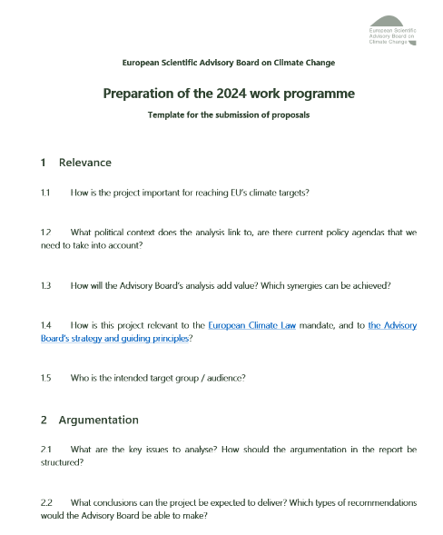
How to fill it out
In the inception phase you fill out as much as you can. Please be aware that the level of knowledge gained through the following phases will help with the detailed description of the project in the project description.
In overall terms what is the:
- Relevance, aim and scope?
- Argumentation and key issues to analyse?
- Timing?
- Resources?

Structure and content
Find the template and guiding questions here.

3.8 Discussion at Advisory Board meetings
Organisation of Advisory Board meetings and facilitation of discussions

Purpose of the discussions at Advisory Board meetings
Meetings in the Advisory Board are a forum where all the Advisory Board’s activities are discussed, including projects. Advisory Board meetings are held continuously during the project, and it is typically here where the Advisory Board members can engage in professional discussions and indicate the direction of a project. Discussions thus take place both in depth and in breadth, and the organisation of the discussions at the Advisory Board meeting depends on how far a project has come, which issues are relevant to clarify and what the Advisory Board's other agenda is.

Participants in the meeting
The Advisory Board members and members of the Secretariat participate in the meetings. All members of the Secretariat participate, so that it is subsequently possible to implement the Advisory Board members' requests for quality and progress of the project to the greatest extent possible. The Secretariats is also present in order to answer questions and provide professional advice to the Advisory Board.

Expected duration
Depends on issues in the project and the other agenda items of the Advisory Board meeting.

Step-by-step
1 Before: Preparation of the Advisory Board meeting
Identification of issues and form of meeting: Prior to the Advisory Board meeting, relevant issues are identified. After this, the form of the meeting is defined, which can be physical or virtual. It may also be an option to run a written procedure if the circumstances require it. Both parts are coordinated with the project lead and subgroup champion as well as any strategic partners.
Purpose: Discussions at Advisory Board meetings require thorough preparation. The discussion should be carried out with an intention for the Advisory Board to either steer, make decisions on proposals and / or agree on the conclusions and recommendations of an analysis (consensus).
Materials for the meeting: May include, for example, presentations, background notes, analysis drafts and relevant project tools, depending on where in the process the project is. As part of the Advisory Boards strategic perspectives, it will generally be a good idea for the Advisory Board to relate to an updated narrative. Be aware of limiting the amount of material and prepare a reading guide when sending draft text prior to the Advisory Board meeting. Feel free to prepare a series of questions that Advisory Board members are asked to consider before the meeting.
Facilitation and script: In the project team, you should consider whether the discussion should be a joint table discussion, or it can create value to facilitate standing brainstorming, peer discussions or the like. Roles at the meeting must be clarified in advance and agreed with the chair of the Advisory Board, who facilitates the discussions. An annotated agenda is drawn up for the chair of the Advisory Board in collaboration with the project lead, which can be discussed at a pre-meeting.
2 During: Facilitation of discussions
The discussions at the Advisory Board meeting should aim for all Advisory Board members to have the opportunity to make their contribution to the project – both in breadth and in depth. It is important that a common understanding is achieved among stakeholders to the project and relevant issues, as well as how these are best handled.
3 After: Follow up
After the discussions at the Advisory Board meeting, minutes of the meeting are drawn up and the project team joins the project lead to find out how the Advisory Board’s input is handled. There may be a need for a follow-up meeting involving the members of the Advisory Board and the Secretariat.

Scoping phase
Guidelines and
templates

Scoping phase

Purpose of the scoping phase

The purpose of the scoping phase is to clarify the project’s relevance (related to both the political context and the Advisory Board’s mandate and strategy), aim, scope and methodological approach, and to organise the project in terms of planning, resources and stakeholder management.

The scoping phase begins after the Advisory Board members have given the green light.

Key elements to consider in the scoping phase:
- The project’s relevance in view of the science and policy context and the Advisory Board’s mandate, vision and strategy (= “why?”)
- The project’s aim and scope in terms of topics to be included, including a preliminary argumentation and key messages (= “what?”)
- The methodological approach (= “how?”)
- The target audience (= “for who?”)
- The project team and respective roles and responsibilities (= “by who?”)
- The planning/timeline (= “when?”)
- Relevant stakeholders to consult at different stages of the project
- Potential risks to the project’s success and measures to mitigate those risks

Key activities in the scoping phase

Members of the Advisory Board and of the Secretariat will get assigned different roles and responsibilities for the project, as outlined in the project framework. In line with their respective roles and responsibilities, they will undertake a range of activities to fulfil the purpose of the scoping phase as described in section 5.1. Key activities per role include:

Secretariat’s project team
- first mapping and review of scientific literature, reports and policy documents to get an overview of the policy and knowledge landscape, and to identify how the Advisory Board could add value
- mapping of stakeholders and first consultations with external experts and stakeholders (similar purpose as the previous bullet point)
- coordination with the subgroup champion
- organisation of internal meetings (kick off meeting(s), subgroup meetings)
- draft the tentative narrative
- draft the project description
- draft outline

Subgroup champion
- coordination with the project team (primarily via the project lead)
- all other activities relevant for subgroup members

Other subgroup members
- Participation in subgroup meetings
- Participation in meetings with stakeholders where relevant
- Providing written feedback

Advisory Board
- Participate in discussions during Advisory Board meeting

Key deliverables in the scoping phase

- The project description and supporting documents that cover the project’s set-up and organisation in terms of:
  - relevance, aim and scope
Brief summary in project description, to be elaborated further in tentative narrative
  - methodological approach
  - tentative key messages
  - target audience
  - timing (incl. milestone plan)
  - resources, i.e. an overview of the project team, the subgroup, and potential external resources (e.g. contracting)
  - stakeholder management (incl. stakeholder strategy)
  - risk management (incl. risk analysis)
- The tentative narrative that describes in more detail the project’s:
  - relevance (given the scientific and policy context, and the Advisory Board’s legal mandate and strategy)
  - aim and scope of the project
  - methodological approach
  - preliminary conclusions and key messages
- Report outline/table of content
- Overview of relevant literature to consult (e.g. in a Sharepoint folder, or a reference list in Zotero)
- Slides that summarize the project description for presentation to Advisory Board

Requirements for a change in phase

- Approval by the Advisory Board of the project description
- Approval by the Advisory Board of the tentative narrative
- Approval by the Advisory Board of the outline of the report

The kick-off meetings

During the scoping phase, two kick-off meetings will be held: one internally within the Secretariat, and one with the members of the project subgroup meeting.

The purpose of the internal kick-off meeting
The internal kick-off meeting in the Secretariat is held after the project proposal is adopted, to have a first discussion on the main elements (see 5.3) of the project description. The aim is to create the common direction for the project team and ensures that the project team has a mutual understanding and alignment of expectations in relation to the scope, aim, resources, milestones, the team roles and responsibilities, their way of working and the timeline.

Participants in the internal kick-off meeting
It is recommended that the project lead, project team, Head of Secretariat and communications lead participates in the kick-off meeting.

Expected duration
1-2 hours

Remember before, during and after the kick-off meeting
BEFORE: PREPARATION OF THE MEETING
Before the meeting it is the project leads role to send out an invitation and materials in advance so everyone in the team has the time to prepare.

Preparation materials:
Can for example be the agenda, reflection questions, draft project description and tentative narrative.
Planning of the meeting:
A good kick-off meeting requires good preparation. It is important to plan the facilitation, the processes, and the timings so it is creating impact.
DURING: FACILITATE THE MEETING
The impact of the meeting depends to a large extend on how the meeting is facilitated and whether the participants feel that a common understanding of the project and honest reconciliation of expectations will be established.

Find the template for the agenda here.
AFTER: FOLLOW UP

It is recommended that the project lead sends out a summary of the decisions after the kick-off meeting.
Cadence of the meetings: In order to support the progress in the project and a continuous dialogue in the team it is recommended that weekly meetings and touch-points are placed in the calendars.
On-boarding of new project team members:
It is the project lead’s role to ensure a good on-boarding for new project team members.

The subgroup kick-off meeting
After the Secretariat internal kick-off meeting, and after initial research and drafting of the projection description, another kick-off meeting is held with the subgroup. The aim of this kick-off meeting is to discuss the draft project description and tentative narrative, before these are shared with the full Advisory Board for final discussions and adoption.

  - The project description

The purpose of the project description
The purpose of the project description is to mature an idea and to form a concrete overview of what the project will entail (see main elements in 4.3), which the Advisory Board will decide on. The initial project description is already prepared in the inception phase, and is then further elaborated during the scoping phase.

How to fill it out
The project lead is tasked with preparing the project description. This often includes involving relevant colleagues and possibly selected Advisory Board members who can help frame the project.
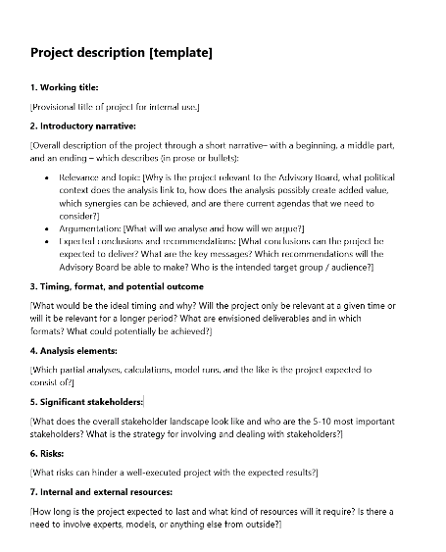
The project description template includes guiding questions around the following topics:

- Relevance, aim and scope
- Methodological approach
- Tentative key messages
- Target audience
- The timing and format
- Stakeholder engagement
- Risk analysis
- Resources

The project description should only contain a brief summary of 1-3 and then the tentative narrative will elaborate further.

The process may involve feasibility studies etc. This is where you get an indication of whether the hypothesis will hold and what challenges there may be along the way in the project. It is also here that some considerations are made about how to carry out the analysis, in which context the analysis is to be included (data, political topics, etc.), how the analysis is to be presented and to whom it is communicated.

In relation to the execution of the project itself, it is considered which resources are available and when, and whether the project requires external resources and, if applicable, the budget for this. Finally, any risks associated with the project are considered and a preliminary timeline is drawn.

It is all coordinated with the Secretariat and summarised in a project description, which needs to be approved by the Advisory Board members.

Tools and templates
Find the template and guiding questions here.

Narrative of the report

The purpose of the narrative
The purpose is to create a common understanding of the analysis internally within the Advisory Board and between the Advisory Board and the project team throughout the process.

The narrative creates a short, clear, and comprehensible overview of 1) the relevance, aim, scope, 2) approach and content of the analysis, and 3) tentative messages and conclusions.

The narrative complements the project description, which covers the more practical organisation of the project, as well as the report outline which covers the structure of the report.

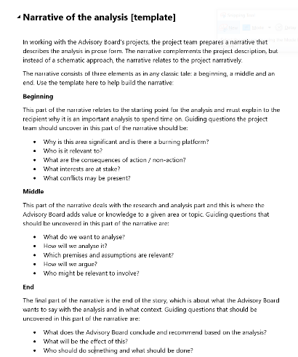
What is a narrative?
The narrative is the backbone of the project that describes the report in short and concise prose.

Research shows that storylines are an efficient way to transfer knowledge and communicate messages because they enhance knowledge acquisition.

The most basic structure of a narrative contains three elements 1) a beginning, 2) a middle and 3) an end. This structure is easily recognisable and decodable.

Below the content of each section is described in further detail.

Structure of narrative | Tentative report narrative | Fictional analogy “crime story”
Part 1.  (beginning) | Relevance, aim and scope of the report  - Explains the relevance of the topic in relation to the current policy context and the Advisory Board’s mandate.  - It specifies a clear scope and focus of the report  - Explains the usefulness of the topic and what the Advisory Board is hoping to achieve with this report. | A mystery is revealed  -The problem surfaces and the crime scene is described  -The type of crime is identified and the context in which the crime is committed is uncovered  -Works as a motor for the rest of the story
Part 2.  (middle) | Analytical approach  -Describes the methodology and the analytical approach the Advisory Board will use to carry out its analysis.  -Explains the chain of the argument and the different steps the Advisory Board intends to take before arriving at its conclusions and recommendations.  - Argues for and against specific solutions. | Investigation begins  -The clues given in the beginning of the story determines the focus of the investigation  -The detective sets out to solve the mystery using a rational deductive approach  -The signs and proofs are logged and documented in order to solve the mystery and to be used in the final case against possible perpetrators.
Part 3.  (end) | Tentative key findings and recommendations  -This concluding section outlines the conclusion of the analysis and the key recommendations (with their rationale) for a future policy and governance  -The recommendations are concrete actionable policy advice that clearly identifies who should be doing what and for what purpose.  -Ideally, the recommendations should be ordered to form a logical sequence. | Mystery is solved  -The conclusion of the investigation is wrapped up and the crime is solved.  -(Recommendations on how to handle the situation and how to avoid the problem in the future are presented.)

The narrative evolves during the whole project
In the inception phase, the narrative is included in the project proposal and takes the form of a simple, tentative narrative e.g. in bullet form. In the scoping phase, the narrative is developed as a separate product in parallel to the project description. In the analysis and drafting phase, it is further elaborated to present a clear outline for content, delimitation, and reconciliation of expectations with the Advisory Board.

As the project progresses, more is added to the narrative. When the project team enters the analysis and drafting phase, the objective is to have a solid narrative that becomes more and more precise and mirrors the draft report to be used actively in the dialogue with the Advisory Board and works as the basis for discussions at Advisory Board meetings.

Eventually become the narrative can be converted into the publication's summary, conclusions, and recommendations.

Tools and templates

Find the template and guiding questions here.

The outline of the report

TBD

Stakeholder engagement – Mapping, prioritising, and involvement of key stakeholders

The purpose of stakeholder engagement
All Advisory Board reports are science to policy and are thus developed in an academic context as well as a political reality. This makes it important to gain a good understanding of the stakeholder landscape to determine which stakeholders are particularly important for the project, and how they can inform:

- The scientific context of the project
- The policy context of the project

The purpose of stakeholder management is to continuously identify which expert and political stakeholders that are important for the project, to decide on a plan that describes how the individual groups of stakeholders are involved and/or handled in the individual phases of the project and to continuously carry out various activities to ensure efficient stakeholder management.

In all activities dealing with the involvement and management of stakeholders, it is important to keep the Advisory Board’s independence in mind and to ensure transparency. In general, it is preferable to plan most interactions with stakeholders in the early phases of the project to avoid any speculation that certain stakeholders could have had any direct influence on the final recommendations.

Stakeholder mapping and analysis
The standard practice in stakeholder mapping is to map stakeholders according to their degree of influence and interest and / or knowledge about a given topic. Mapping stakeholders according to these two dimensions will help identify the most appropriate engagement strategies for different stakeholders.
Stakeholder influence by knowledge matrix
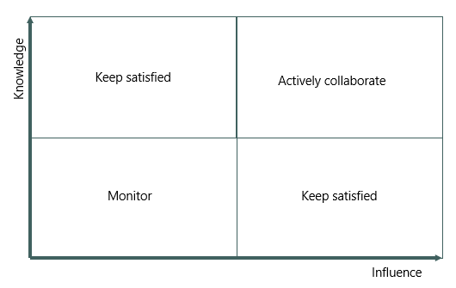
Those stakeholders who have high influence and who can inform the project are likely to take an active stance and can either help bring about change or prevent it. Therefore, engagement with stakeholders in this category should be careful, sustained and active collaboration. Stakeholders who can inform a project should be involved in its early phases, while those who can influence the outcome should be informed at the appropriate time. Minimal effort is expended on stakeholders who can neither inform the project nor influence its outcome. They are likely to remain passive and may change their position over time, and therefore it is enough to monitor them.

Stakeholder categories
As outlined in the Advisory Board’s stakeholder engagement policy, the following stakeholder categories are particularly relevant to the work of the Advisory Board:

- EU institutions: The Advisory Board is an independent body providing the EU with scientific knowledge, expertise and advice relating to climate change. As a point of reference for the EU, the advisory Board prioritises having a continuous dialogue with the main decision-making institutions (Commission, European Parliament, Council), as well as other bodies and agencies relevant to the work of the Advisory Board.
- Scientific community: The advisory Board contributes to the exchange of independent scientific knowledge within the EU, with a primary focus on engaging with the EU scientific community and organisations that have a science-based approach to climate action, in particular at the EU level. In cases where expertise from certain regions of the European Union are underrepresented in the Advisory Board, priority can be given to engaging with scientists and science-based organisations, such as national science academies, from those particular regions.
- National climate advisory bodies: the Advisory Board closely cooperates with national climate advisory bodies that provide expert scientific advice on climate policy in the EU. As these bodies are operating at the science-policy interface at the national level and are very similar to the Advisory Board, often with overlapping mandates, a regular engagement with this stakeholder category present the double benefit of informing national policy debates with EU-level considerations, and of strengthening the Advisory Board’s advice with national results and perspectives.
- Other stakeholders: The Advisory Board also engages with a broad range of stakeholders outside of EU institutions and the scientific community to share research and exchange feedback on EU policies and initiatives. These include, for example, national governments and parliaments, think tanks and non-governmental organisations, social partners, industry associations, EU citizens, etc.
- Media: The Advisory Board's role is to contribute to policy discussions with timely and relevant recommendations. A public profile aids the Advisory Board in achieving impact and raising awareness of climate change and its impacts. The Advisory Board maintains a media presence and enriches the public debate by making its members available for comments and interviews. Further details on how to engage with the media can be found in the Advisory Board’s Communication Policy.

Stakeholder management
In the scoping phase, it is a good idea to present the stakeholder landscape and a draft stakeholder management plan at a Subgroup meeting to get further input and assessment of whether there are other significant stakeholders that should be involved.

It is the project lead’s responsibility to involve the entire team in the management of stakeholders and to regularly revisit the stakeholder analysis and assess whether engagements with stakeholders are appropriate.

If certain stakeholders have a high impact on the potential outcome of the report, the project lead can seek strategic steering from the Subgroup champion, the head of the Secretariat as well as the communication lead. The communication lead can assist with facilitating the stakeholder mapping and analysis.

Stakeholder engagement – step by step
MAPPING AND ANALYSIS OF THE STAKEHOLDER LANDSCAPE

Involve the entire project team in a brainstorm about the stakeholders. Which stakeholders can influence or be influenced by the conclusions and recommendations of the analysis? Who should be involved, heard, or informed? Remember a distinction between stakeholders who are important in terms of expert input, and those who play both an expert and strategic-political role.
STRATEGY AND PLAN FOR INVOLVEMENT OF STAKEHOLDERS

Based on the initial stakeholder analysis, the project team can start by creating an overall strategy for: Which groups of actors should be managed in what way and be specific about the activities (e.g., 1:1 meetings) and when during the project? What kind of communication? Once the overall lines have been determined, a detailed plan is drawn for stakeholder management in the individual phases of the project.
ONGOING MANAGEMENT OF STAKEHOLDERS

Dealing with stakeholders is typically done through interviews and meetings. In 1:1 meetings, where there is a particular focus on knowledge sharing and gathering, it is important to take minutes of the meetings to share knowledge in the team.
When the analysis is nearing its end, the stakeholder analysis must be revisited and assessed against the conclusions of the analysis.

Tools and templates
The tools for stakeholder management are a classic stakeholder analysis and strategy/plan for managing the stakeholders.

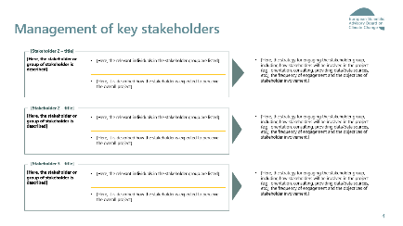
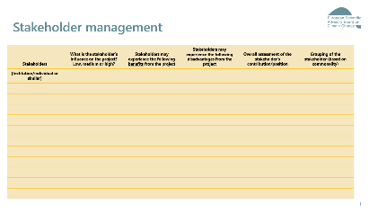
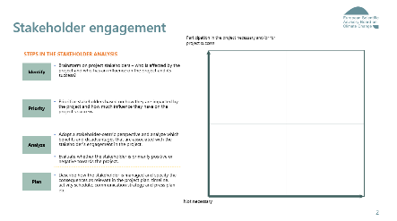
Find the template for the stakeholder engagement here.

Risk analysis

The purpose of the risk analysis
The purpose of the risk analysis is to make the milestone plan robust. It is to define weaknesses in the project and find ways to prevent them.

Mapping of risks takes place in the scoping phase, where an initial risk analysis is included as part of the project description. The project team brainstorms on challenges and problems that can hinder a well-executed project achieve the expected results. These could for example include risks related to the timeliness of the publication, perception by stakeholders, lack of expertise or resources, etc.

Identifying and mitigating risks
When working with risk analysis its is often easier to identify risks, rather than find concrete ways to mitigate those risks and include specific measures in the planning.

When the overall risk analysis is done it is a good idea to present it to the Advisory Board to get their input and assessment of how to handle potentially high risks for the project.

Risk analysis – Step by step
ONGOING MANAGEMENT OF RISKS
The risk analysis is dynamic and changes through the phases. It is the project leads responsibility to make sure that the project team revisits and assesses the risk analysis several times though out the project.
The project lead must raise awareness about higher risks to the Advisory Board and have their input on have to handle them.

STRATEGY AND PLAN FOR
PREVENTING OR MITIGATING THE RISKS
Based on the initial risk analysis, the project team can start by creating an overall strategy for which risks are to be prevented and which should be mitigated and how. Once the big lines have been defined, a detailed plan is drawn for the risk management in the individual phases of the project.
MAPPING AND ANALYSIS OF THE IDENTIFIED RISKS

Involve the entire project team in a brainstorm about what risks they identify in the project.
Examine what could go wrong (use a checklist, experience, brainstorming).
Determine the impact of the potential risks by using a classic risk matrix prioritising on the possibility for the risk to happen and the consequence to the project if it does occur.

Tools and templates
The tools for stakeholder management are a classic risk analysis and strategy/plan for managing the risks.
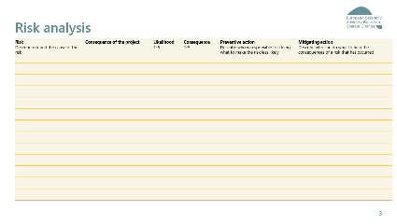
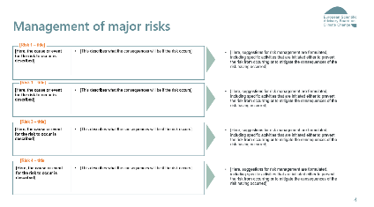
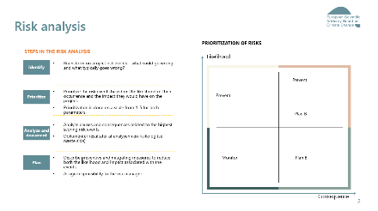
Find the templates for the risk management here.

The planning of the project

Two levels of planning
There are typically two levels of planning in the project. An overall milestone plan that identifies the most important milestones and an activity plan that details the plan with agreed deadlines, activities, and deliverables within a shorter period – typically the upcoming phase. In larger projects with several sub-project leads, it makes sense for each sub-project to draw up a specific activity plan.

The purpose of the milestone plan
Good project management requires a robust milestone plan. The overall milestone plan must clarify when the most important milestones and main deliverables in the project are expected. Typical milestones will be: "the project description has been approved by the Board", "extended narrative has been discussed in the Board", "interviews have been carried out with the 10 most important stakeholders", "draft of chapter x-x has been sent for review in the Secretariat".

The plan must be clear to the important internal stakeholders, being the Advisory Board, the project lead and the project team. The milestone plan must define the project's start and end, clarify when the Advisory Board will be involved and consider the significant events that ensure the publication's relevance

When there are changes to a project, it is the responsibility of the project lead to seek advice from the head of Secretariat regarding the prioritisation of time and tasks. If more ressources as well as adjustments in time or scope is needed to reach the milestones, this has to be agreed with the head of the Secretariat.

If there is a need for adjustments to the milestone plan, the implications are discussed in Secretariat meetings as well as Advisory Board meetings.
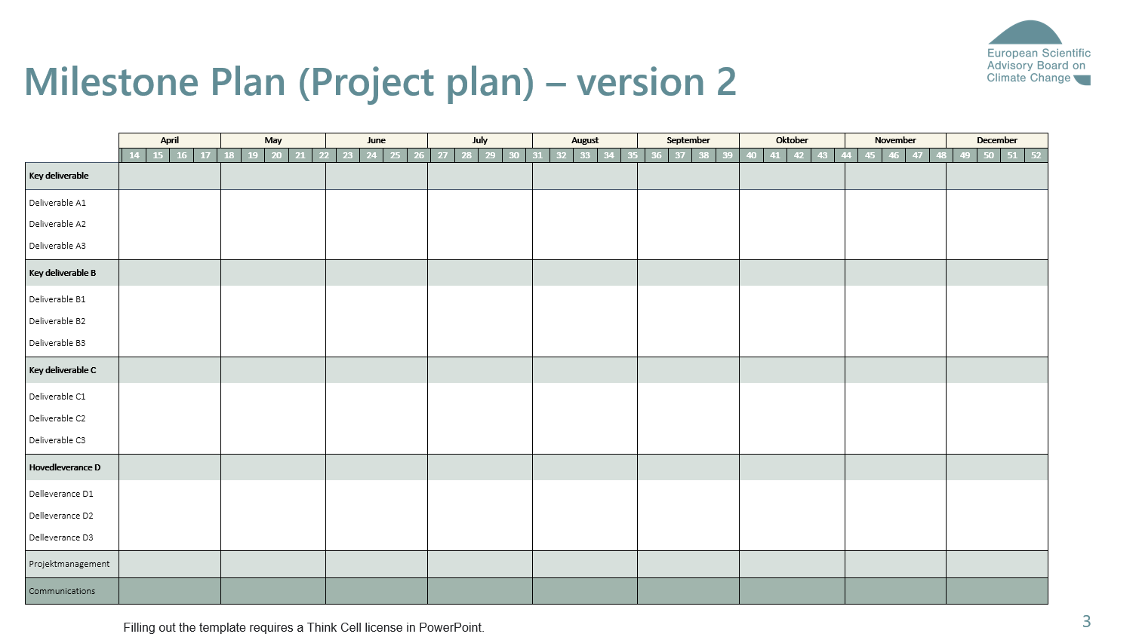
The activity plan
To make efficient use of the time, the project lead prepares an activity plan with details on tasks, responsibility, agreed deadlines, and deliverables within each phase. The detailed activity plan should include the various internal reviews and validation with Secretariat colleagues, Subgroup members and Advisory Board members.

In larger projects with several sub-project leads, it makes sense for each sub-project to draw up a specific activity plan for each phase.

A separate plan for the final production of the report and the communication and outreach activities should be prepared together with communication lead.

The more detailed activity plans (Gantt charts) could be made using Microsoft Project. All activity plans must be continuously adjusted as changes occur in the project.

Tools and templates
Find a template for the milestone plan here and the more detailed Gannt chart here.

Step-by-step approach to the scoping phase

Step 1 – bilateral with the subgroup champion to discuss the following topics:
- inform him/her that the work has started, and who will be in the Secretariat’s project team.
- discuss the timeline of the scoping phase (when to organize subgroup meetings, when to aim for project description approval by the Advisory Board).
- have a first discussion on the project’s scope and aim.
- plan in bilateral meetings for continuous follow-up.
- inquire about relevant sources/experts to consult in the scoping phase.

Continuous coordination with the subgroup champion should be maintained throughout the next steps of the scoping phase (and the project as a whole).

Step 2 – internal kick-off meeting to clarify roles and responsibilities and have a first discussion on the main elements of the project description (see also 4.5). Specific focus could be put on mapping of stakeholders to consult during the scoping phase.

Step 3 – stakeholder engagement plan to identify relevant stakeholders to consult – in particular in the scoping phase.

Step 4 – preliminary research and stakeholder consultations with as primary aim getting a good understanding of:
- policy context and upcoming policy milestones to influence
- potential topics to include + strategic angles to take
- existing and upcoming publications on the topic (to identify relevant sources and potential knowledge gaps)

Step 5 – first drafting of the project description (including supporting documents) and tentative narrative to structure the thinking so far and as a basis for further discussions.

Step 6 – discuss the v1 draft of the project description and tentative narrative both internally within the Secretariat and bilaterally with the subgroup champion to ensure alignment.

Step 7 – update the project description (including supporting documents) and tentative narrative in function of the discussions internally within the secretariat and with the subgroup champion. The end result should be sufficiently mature to prepare discussions with the subgroup and Advisory Board.

Step 8 – kick-off meeting subgroup to have a first discussion on the project description, tentative narrative and supporting documents (stakeholder strategy, milestone plan, …) and to gather the subgroup members’ feedback. The documents should be sent at least 1 week prior to the subgroup meeting to allow for an informed and prepared discussion.

Step 9 – updating of the project description (including supporting documents) and tentative narrative based on the outcome of the subgroup discussions. If necessary further iterations with the subgroup could be foreseen. The updated version is circulated within the Secretariat for a final review before being sent out to the Advisory Board.

Step 10 – discussion + approval of the project description and tentative narrative by the plenary Advisory Board to get final alignment within the Advisory Board on the project’s tentative narrative and project description, which would imply the end of the scoping phase and the start of the analysis and drafting phase. The documents should be sent at least 1 week prior to the board meeting to allow for an informed and prepared discussion.

Analysis & drafting phase
Guidelines and
templates

Analysis and drafting phase

5.1 Purpose of the analysis and drafting phase

The analysis and drafting phase constitutes the production part of the project, where an overall final product is prepared in the form of a report, a briefing or an analysis as well as supplementary communication products.
Quality and risk management are important focus areas, and the project's progress is continuously evaluated. If the basis, scope or time horizon of the project changes, a meeting on the strategic perspectives is facilitated in the Advisory Board with a purpose to potentially
reframe the analysis.

5.2 Key activities in the analysis and drafting phase

Key activities for the analysis and drafting phase include the collection of evidence from the scientific literature, experts’ consultations, drawing from the Advisory Board’s expertise and support from contractors where needed. Other key activities are the development of science-based policy recommendations. The findings should be synthesised into a coherent narrative and preparation of data charts.
This phase also include reviews and quality control within the Secretariat, with topic leads, Subgroup and the Advisory Board.
Secretariat
- Coordinate drafting
Subgroup
- Guide on specific topics, iterative reviews, and quality control
Advisory Board
- Steer on recommendations

5.3 Key deliverables in the analysis and drafting phase

- updated project description and milestone plan as it will develop through the project
- detailed outline
- contractors’ inputs (optional)
- narrative and draft executive summary
- draft chapters and draft data charts
- report slides to Advisory Board
- draft Communication plan
- final draft

5.4 Requirements for a change in phase

- Approval in the Advisory Board of a final draft.

5.5 Roles and responsibilities in the analysis and drafting phase

Subgroup champion
- Provides guidance to the project lead on strategic and technical matters, provides academic references
- Provides written and oral feedback on draft iterations
- Ensures consistency between Subgroup members’ inputs and overall coherence
- Approves material that is sent to the Advisory Board
- Helps moderate discussions and identify issues to raise with the Advisory Board
Subgroup topic leads
- Provide guidance to Secretariat on specific topic
- Provide academic references
- Provide detailed written feedback on specific chapters of the draft
- Ensure the quality of the draft through mini-iterations
Other subgroup members
- Share technical insights in Subgroup meetings
- Provide written feedback on recommendations and overall draft
Other Advisory Board members
- Discuss narrative and recommendations
- Provide guidance on critical issues
- Provide written feedback on draft
- Adopt final draft
Project lead
- Is responsible for the overall delivery and quality of the project, including overall project management and follow-up in relation to deliveries from other members in the Secretariat, from the Advisory Board or from external partners.
- Develops the detailed outline of the publication
- Distributes analytical tasks between project team members
- Defines tasks for external contributors where applicable
- Coordinates the drafting, including reviews by Secretariat and Advisory Board, while ensuring efficient doc. Management
- Contributes to the drafting, coordinates with topic leads for guidance and reviews, updates draft to address feedback from Subgroup members and from the Advisory Board
- Drives the continuous improvement of the narrative, ensures overall coherence of the draft, alignment with initial objectives & with other projects
- Reviews and harmonises different chapters, to ensure overall quality, internal consistency and to avoid overlaps
- Reports to the Subgroup and to the Advisory Board in coordination with the champion, identifies critical points of discussion and decision, prepares agendas/slides
- Plans engagement with stakeholders for consultations and dissemination, and coordinates with Communication lead to organise dissemination activities
- Updates planning regularly

Project team
- Is responsible for part of the delivery of the project
- Provides input to the analysis and drafting in coordination with project lead
- Coordinates with topic leads where relevant
- Updates draft to address feedback from Subgroup members and from the Advisory Board
- Reviews drafts for quality control and improvements
- Supports the coordination of the Subgroup in case of unavailability of the project lead
Head of Secretariat
- Controls the quality of drafts and provides guidance to project lead to improve drafts, in particular the executive summary
- Provides written feedback on drafts
- Provides guidance on critical issues to the project team
- Supports the development of the comm. plan
- Signs off drafts before submission to the Advisory Board
Communication lead
- Reviews drafts and provides feedback
- Supports the development of the communication plan and the organisation of dissemination activities
Other Secretariat members
- Review near-final draft chapters for proofreading, quality control / quality assurance and improvements
- Support from Secretariat assistant to schedule presentations to stakeholders and practical arrangements (e.g. meeting rooms, webinar)

5.6 Key questions – which the project team is expected to consider
- Have we become wiser along the way, and is there a need to revisit the original scope through a meeting on strategic perspectives in the Advisory Board?
- What recommendations should we make at the end – how specific should they and the specific wording be?
- When and how do we involve the Advisory Board?
- What is the right format for the final delivery and documentation?
- Who must ensure the quality of analysis and product deliverables – and how?
- Are there controversial conclusions that require us to revisit our stakeholder engagement plan?
- Are the key findings and recommendations sufficiently backed up by a robust and convincing argumentation?
- Are the different chapters sufficiently consistent (in terms of lengths, level of detail, structure, writing style, …)?

5.7 Evolution of the draft

Purpose of the evolution of the draft
The purpose of this section is to ensure the alignment of the draft with the narrative, the grounding of the analysis into academic references, the buy-in and quality control from the Subgroup and Advisory Board, and the harmonisation of the language and visual identity across reports.

Evolution of the draft – Step by step
1 From the initial outline to the draft
Tentative outline: In the scoping phase, the tentative narrative is reflected into a tentative outline, where the structure aims at following the flow of the argumentation. The tentative outline would usually fit on 1 slide or 1 page. It includes the topics that each chapter will cover, and some bullet points describing what the analysis will include in each chapter.
Detailed outline: When the analysis & drafting phase starts, the project lead is responsible for further developing the tentative outline into a more detailed outline, which includes sub-chapters and more detailed research questions. The detailed outline is discussed in the Subgroup and updated iteratively.
“Skeleton”: The detailed outline eventually evolves into a more detailed document: the ‘skeleton’. This document includes for each sub-chapter:
- title,
- tentative key message,
- list of bullet points describing what the analysis will cover,
- list of academic references,
- placeholders and visual examples of data charts, tables, diagrams,
- and list of tasks for contractors where applicable.
Draft chapters: When the sections have been well defined and approved, the drafting tasks can be distributed amongst the members of the project team.

2 Literature review and referencing
Collection of references: All recommendations developed by the Advisory Board are based on scientific evidence, and hence require a review of the available scientific literature. Academic references are collected from the initial desk research, suggestions from Subgroup members and from consultations of experts. To collect input from Subgroup members, a best practices is to develop a preliminary list of possible sources within the Secretariat, which is then shared for feedback and additional input with Subgroup members early on in the drafting phase. This preliminary list can be structured according to different topics, types of sources (scientific articles, databases, grey literature, …) and chapters in the report.

In order to search for further references, the project team can use JRC’s TIM Analytics text mining tool.

Document management: The relevant scientific papers and reports can be saved on the Subgroup SharePoint folder, using the following format to allow chronological sorting and readability:
[YYYY-MM-DD] [Name of first author et al. or name of organisation] – [Title]
Format of references: Bibliographic references should be reported in the standardised format in order to comply with the EEA writing manual, for example:
- Journal article: Rayment, M., et al., 2009, The economic benefit of environmental policy, final report to European Commission DG ENV, Brussels.
- Report: UNEP, 2012b, The global chemicals outlook: towards sound management of chemicals, United Nations Environment Programme, Geneva, Switzerland.
- Regulation: EU, 2009, Directive 2009/147/EC of the European Parliament and of the Council of 30 November 2009 on the conservation of wild birds (OJ L 20, 26.1.2010, p. 7).
- European Commission communication: EC, 2008, Communication from the Commission to the European Parliament, the Council, the European Economic and Social Committee and the Committee of the Regions ‘20 20 by 2020 — Europe’s climate change opportunity’ (COM (2008) 30 final of 23 January 2008).
- Website: EC, 2014g, ‘European Green Capital’, European Green Capital (http://ec.europa.eu/environment/europeangreencapital/index_en.htm) accessed 9 March 2017.

Adding references: References are added as in-text citations. The text displayed in brackets in the text includes the name of the author/organisation and the year of publication. The references are integrated into Microsoft Word with an add-on software called Zotero. Information on how to install and use Zotero is available on the EEA intranet. It is recommended to start using Zotero at an early stage of the drafting, in order to avoid time consuming referencing later on.

A list of Zotero do’s and don’ts is available on the Secretariat Sharepoint.

3 Writing
Structure of the argumentation: In order to ensure the clarity and readability of the report, the authors should thrive to focus on a single message per paragraph. The overall argumentation of the report would usually be structured around the Advisory Board’s ‘needs – gaps – fixes’ approach. Similarly, each paragraph can be structured around:
- problem (‘why’),
- evaluation of options
- and recommendation or conclusion.

Tone of voice: Policy recommendations can take the form of ‘The Advisory Board recommends that…’, and should always be based on scientific arguments.
The reports of the Advisory Board should be accessible to the general public, and it is useful to include introductory text on the context to ensure a sufficient level of understanding of the issues by the reader. When using technical terms, they should be first introduced and explained in the text.

Harmonisation: When the project lead distributes drafting assignments, it can be useful to agree early on with the project team on:
- the indicative number of words per section,
- key terms used throughout the report,
- years of reference for the data analysis
- and units.
The project lead is expected to set enough time aside to review all inputs and edits, harmonise the language where needed and ensure the coherence of the argumentation throughout the report. The project lead should also ensure the coherence with past and work-in-progress reports from the Advisory Board, including terms and units.

Glossary and abbreviations: Key terms can be defined in a glossary. Definitions are based on the IPCC definitions where possible, or where needed can be drafted by the project team, discussed and validated by the Subgroup and Advisory Board. All definitions should be consistent across reports.

Abbreviations and acronyms should be avoided as much as possible. In the case where some term appear very regularly in the text, their abbreviations can be added to a list of abbreviations at the beginning of the publication.

Writing guidelines: When drafting and editing text, the project team should be aware and follow the EEA writing manual, which includes rules such as punctuation, units, citations, image credits, etc. The spelling should be based on UK English and not US English (e.g. ‘organise’ not ‘organize’).
The project team can also refer to the Interinstitutional Style Guide from the Publications Office of the EU where relevant.

Data processing:
Add guidelines on data handling, processing, analysis, data quality control, check coherence of numbers across report (existing reference document?)

Visual identity: In order for all outputs of the Advisory Board to have a harmonised visual identity, the project team should refer to the Advisory Board’s visual guidelines, which includes a colour palette, fonts, logos, icons, etc. The following templates are available:
- report template,
- briefing paper template,
- letter template,
- data charts template
- and slide deck template.

It is recommended that the project leads starts using the Advisory Board report format as soon as possible, in order to avoid time consuming formatting later on. It is recommended to start from the latest previous Advisory Board report, as it might include further improvement and fixes compared to the original template.

It is also recommended for the project team to use the data chart templates as soon as possible (including colours, font, lines thickness, gridlines, size of charts, etc.) in order to avoid time consuming formatting later on.

4 Collaboration with external contributors
Request for services: The Secretariat can reach out to external contractors to contribute to the analysis. The project lead then needs to defines the tasks to be performed via the request for services template, including:
- background and objectives of the project,
- description of tasks, as specific as possible with a precise scope,
- format of the deliverables,
- expertise required,
- timeline
- and budget.
The development and approval of the request for services, processing by the administrative team, reception of tenders and signature of the contract can take over a month to be completed.

Planning: When the contract is signed, the project lead schedules and prepares a kick-off meeting to clarify the tasks. The project lead adapts the planning to ensure enough time for reviews of the contractors’ draft by the Secretariat and by the Advisory Board, and enough time for contractors to perform iterative adjustments. The cut-off time for receiving inputs from contractors should be clear from the start, in order to avoid delaying the drafting.

Steering and quality control: The Subgroup should be consulted on the definition of tasks, clarifying or raising particular points of attention at the start of the contract, and reviewing drafts from contractors where relevant.

The project lead and project team are responsible for controlling the quality of the inputs provided by contractors, including data quality.

Parallel publications: In the case where the contractors wish to issue a publication in relation with the work done for the Advisory Board, the project lead should coordinate with them in order to ensure:
- the inclusion a disclaimer,
- an opportunity to review the text and align messages
- and a publication date on the same day or after the publication of the Advisory Board’s report in order to preserve the independence of the Advisory Board.

5 Quality assurance and quality control
At each step of the drafting process – from the outline, skeleton, to the draft chapters – the project team is responsible for making sure that the text integrates discussions from Subgroup meetings and feedback from Subgroup members. Each chapter should be submitted to the following steps of internal review:
- initial guidance from Subgroup meeting, Subgroup champion or topic lead before drafting,
- review by project lead to ensure harmonisation,
- review by Secretariat colleagues working on related topics, and/or by the head of Secretariat and communications lead, where appropriate,
- review by the Subgroup and approval by Subgroup champion,
- review by the Advisory Board
- quality control on final text by Secretariat colleagues or Subgroup where appropriate.
At each step of the internal review, the project team updates the text to address feedback from colleagues. The project team should ensure that each part of the text has been reviewed by at least two members of the Advisory Board. The project lead is responsible for planning enough time for colleagues to review at each step.
+Maybe add standard QA/QC procedures

5.8 Strategic review

Adapting the scope and the focus of the analysis

The purpose of the strategic review
In its work, the Advisory Board ensures that the overall direction for a project is fit-for-purpose, i.e., that the subject area, focus, and underlying analyses are fit to deliver on the aim of the project as defined during the scoping phase, and that this aim itself is still relevant in the continuously evolving context.
Along the way in a project it is important to regularly rise to a helicopter view and assess whether the project covers all relevant aspects and whether all relevant consequences are adequately explained.
As one of the most important tools for this, the Advisory Board has defined a process for “strategic review”. This means that the Advisory Board will have the opportunity to jointly take stock, revisit the focus, scope, and approach, and either confirm the original choices or adjust the scope of the project by adding further (sub)analyses or further narrowing down the scope.

When is it time for a strategic review?
The need for the Advisory Board to do a strategic review in the analysis and drafting phase and revisit the field of research through the review may occur because of new realisations that have arisen in the Secretariat in connection with the project work. The need may also arise from new analyses from other players or other political conditions/external changes that mean that the analysis product should be changed to ensure that the publication will continue to be relevant and have the desired impact when it is published.
It is important to point out that a revisit/adjustment of the scope and delimitation of the analysis in the analysis and drafting phase does not mean that we jump back into the previous scoping phase. On the contrary, it is a completely natural development in any analysis project, where you ensure quality and relevance by continually raising yourself up to the helicopter view and qualifying or validating the context of the analysis.

The strategic review – Step by step
1 New realisations in the project
It often happens that we become better informed as calculations are carried out and the analysis takes shape. When we get realisations that give opportunities to adjust the narrative that the Advisory Board has last discussed, it is the project team’s responsibility to facilitate a meeting on the strategic perspectives in the Advisory Board.
It is just as likely that the Advisory Board will automatically have a discussion on the strategic direction when in an Advisory Board meeting, it can happen when they discuss drafts for the participants and come up with suggestions for new calculations or new implications that should be explored.
2 Follow-up on the Advisory Board’s inputs and conclusions
In practice, it is not always the case that clear conclusions emerge from the Advisory Board’s discussions on the strategic direction. The report is an occasion for the Secretariat to clarify how the Advisory Board’s input will be worked on.
3 Debrief in the project team with the project lead
After an Advisory Board meeting, where there has been a discussion on the strategic direction, it is a good idea for the project team to meet with the project lead and follow up. What did we hear and how should we incorporate it into our work? What does this mean for the schedule? Do we possibly need follow-up strategic sparring and clarification with, for example, the chair of the Advisory Board? The project team will also consult with the project champion on these issues, after a first discussion within the project team.
4 An updated narrative and reflection of it in the analysis draft
The most important thing about the strategic review is that there is continuous “consent” in the Advisory Board about the overall direction of the analysis. It is the project team’s most important task to translate the Advisory Board’s input into concrete adjustments to analysis and product deliveries in the best possible way.

5.9 Developing the communication plan

Purpose of the communication plan
In parallel with the analysis, in this phase the project lead needs to operationalise the stakeholder strategy developed in the scoping phase into a communication plan, as some high-level meetings might need to be scheduled well in advance (e.g. meeting with the European Commission and European Council).

Liaison and examples of communication activities
The communication plan is developed in collaboration with the communication lead and head of Secretariat. The communication plan may include for example:
- timings to share an embargoed copy with key stakeholders and the media,
- online press briefing,
- in-person presentations to key stakeholders,
- press conference or public webinar,
- online presentations to other groups of stakeholders,
- social media campaign,
- and/or newsletter and mailing list for wider distribution.
The project lead liaises with Advisory Board members to schedule presentations sufficiently ahead of time. The project lead, communications lead and head of Secretariat liaise with stakeholders.

Production- &
outreach phase
Guidelines and
templates

Production and outreach phase

6.1 Purpose of the production- and outreach phase

The purpose of the production and outreach phase is to prepare the final report with proofread text in the right graphic layout and to organise publication activities. Advisory Board members present the report to key stakeholders.

6.2 Key activities in the production- and outreach phase

Key activities in the production- and outreach phase are language editing and graphic design support on charts, diagram, and report layout.
Other activities here are the development of communication materials for the website, mailing, social media, and presentations.
In addition, the project team carries out preparation for speakers and dissemination to stakeholders.
Secretariat
- Coordinate with proofreader and designer
- Prepare presentations and Q&A
- Prepare communications materials
Advisory Board
- Read Q&A
- Present to stakeholders

6.3 Key deliverables in the production- and outreach phase

- Final charts
- Proof edited draft
- Internal Q&A
- Webpage text
- Letters/emails/newsletters
- Social media materials
- Final report
- Slide deck(s) with speaker notes

6.4 Requirements for a change in phase

- Completed implementation of publication activities

6.5 Roles and responsibilities in the production- and outreach phase

Subgroup champion
- Reviews draft communications materials
- Presents the publication to stakeholders
Advisory Board members
- Read internal Q&A document
- Presentation recommendations to stakeholders where relevant
Project lead
- Prepares final file for the proofreader, and coordinates the preparation of data files for the graphic designer
- Coordinates with Communication lead to prepare communication Materials: press release, letter, emails, social media
- Drafts slides for presentations to stakeholders, including speakers’ notes, and updates slides according to reviews with Secretariat and Advisory Board
- Drafts internal Q&A document, and updates according to review with Secretariat and Advisory Board
- Supports Advisory Board members in preparation for presentations to stakeholders
- Presents recommendations to stakeholders where relevant
- Coordinates the preparation of data files for publication, develops and publishes erratum where needed
- Ensures efficient archiving of final files
Project team
- Supports the preparation of data files where applicable
- Support the development of communications materials, presentation slides and Q&A
Head of Secretariat
- Reviews communication materials, presentation slides and Q&A
- Presents recommendations to stakeholders where relevant
Communication lead
- Coordinates with external proofreaders and graphic designers
- Coordinates with media/stakeholders to release embargoed copy / set up webinar where applicable
- Supports the development of communications materials: press release, letter, emails, social media
Other secretariat members
- Read internal Q&A document
- Support from Secretariat assistant with proofreading, graphic design, printing, webinar, website, social media, meetings

6.6 Key questions – which the project team is expected to consider

- What are the recommendations/main messages and the most important sub-messages that needs to be communicated?
- How should the release be publicised?
- Who speaks from the Advisory Board – and when?
- Who must be informed before publication?
- Who should be appointed as responsible for stakeholder management after publication?

6.7 Production

Purpose of the production
The purpose of this part of the project is to finalise the product, and to ensure the quality of the language and the readability of the document.

Production Step-by-step
1 Copy editing
After the approval of the final draft by the Advisory Board, the Secretariat works on the copy editing of the text. This can include minor changes to refine the language, increase clarity, harmonise the tone of voice and terms used, or improve the overall flow of the argumentation. However, the copy editing should not include changes to the substance of the analysis or recommendations. Copy is defined as “matter to be printed,” and a copy editor is responsible for this polishing step. The copy editor can be the project lead, or another Secretariat colleague where relevant. The copy editor scans the written work to identify and correct:
- grammar and spelling,
- tone and style deviations,
- wordiness,
- clunky transitions,
- confusing syntax,
- problematic or misused words,
- uneven flow
- and units format.
2 Layout
When the copy editing is finished, the project lead can proceed to the adjustments to the graphic layout of the document, making sure that all the document complies with the Advisory Board’s visual guidelines, including:
- text body and headings,
- figures, including titles, sources, font, colours, lines thickness, gridlines, size, border,
- tables,
- and alignment of paragraphs.
3 Graphic design
The project lead identifies tasks to delegate to an external graphic designer to improve diagrams, charts or any other visual element. The project lead coordinates with the communications lead to contact graphic designers. It is recommended to plan one month for this step.
4 Proofreading
In parallel with the external graphic design work, the project lead prepares the file to send to the proofreader, who will correct the grammar, spelling and punctuation. It is recommended to not perform further changes to the text after sending it to the proofreader, in order to avoid a time-consuming reconciliation of versions. The project leads coordinates with the communications lead to contact proofreaders from the Publication Office of the EU (OPOCE). Proofreaders need 1 working day per 15 pages (excluding bank holidays). It is recommend to plan at least two weeks for this step. OPOCE will provide an ISBN for each report.
5 Final verifications
When the final text is received from the proofreaders, the project lead integrates the inputs from the graphic designer and performs the final verifications on the document.

6.8 Publication

Purpose of the publication
The publication puts an end to the great work involved in publishing a report or a memorandum in the Advisory Board. It is through publication that the Advisory Boards most important stakeholders, the press and society as a whole gain insight into the Advisory Board’s recommendations and assessment, and the seed is laid for the publication to influence policy development and in the long run create the intended effect.
The publication is typically an intensive process that can be divided into a preparation for the publication, the publication itself and follow-up to the publication.

Publication Step-by-step
1 Preparation and approval of press material and communication products
In the publication phase, the various press and communication activities are started, including preparation of press releases, press preparedness and supplementary communication products, according to the communication plan developed in the analysis phase. All materials are finally reviewed by the communications lead, head of Secretariat and Advisory Board members where relevant. All documents are PDFs in a final format. The project lead is responsible for the delivery of the following communications activities, in coordination with the communications lead:
- presentation slide decks, with speaker notes and preparation meeting with speakers,
- internal Q&A document,
- press release to appear on the Advisory Board’s website,
- letters, emails and newsletter where applicable,
- communications on eventual embargo time, online press briefing and public webinar,
- arrangements for meetings with the European Commission, Council, hearings at the European Parliament, or meetings with other key stakeholders,
- materials for Twitter and Linked-IN
- and the stakeholder mailing list.
2 Publication
Targeting primary stakeholders: Before publication, an embargoed version of the publication is sent to the three primary groups of stakeholders: the European Commission, the Council and the European Parliament. This is the responsibility of the project lead in collaboration with the communications lead.
Uploading material to the website and sending it to the press: The communication lead is responsible for the publication of the report itself.
Events, interviews, etc.: In connection with the publication, the activities agreed with the Advisory Board are carried out, cf. the communication plan (e.g. webinar, press conference, interviews with journalists, etc.).
3 Follow up on the publication
Presentations to stakeholders: An important aspect in ensuring that the publication creates an effect in society is a follow-up orientation and dialogue with selected stakeholders. The preparation of the presentation slides is coordinated by the project lead, together with speaker notes and an internal Q&A document intended for Advisory Board members to prepare for presentations and interviews.
Ongoing dialogue with the chair of the Advisory Board: The project lead and communication lead are responsible for continuously collecting reactions from the press and significant stakeholders (including EU institutions). The chair of the Advisory Board is kept informed on an ongoing basis by head of Secretariat of communications lead.

Evaluation phase
Guidelines and
templates

Evaluation

7.1 Purpose of the evaluation phase

Evaluation of the project with a purpose of learning from where we were successful and where we can improve.
An evaluation meeting is held in the Secretariat and an evaluation discussion is held in the Advisory Board. The head of Secretariat collects both evaluations and ensures that relevant recommendations are shared internally in the Secretariat and reflected in the way future projects are approached.

7.2 Key activities in the evaluation phase

Key activities for the evaluation phase includes the collection of feedback after publication,
evaluation within the Secretariat, with Subgroup champion and/or Subgroup, and with the Advisory Board.
Secretariat
- Prepare evaluation meetings and documents
Advisory Board
- Participate in evaluation meeting

7.3 Key Deliverables in the evaluation phase

- Evaluation matrix

7.4 Requirements for a change in phase

- Report on evaluation

7.5 Roles and responsibilities in the evaluation phase

Advisory Board members
- Participate in the evaluation meeting
Project lead
- Is responsible for identifying best practices to share with the team, as well as gaps and areas of improvement to address in future projects
- Prepares and facilitates the evaluation meetings with the project team within 1 month from production and outreach
- Prepares and facilitates the evaluation meetings with the Advisory Board, as well as possible individual meetings with Subgroup champion and members where relevant
- Finalise evaluation report and proposes actions where relevant
- Report to whole Secretariat on findings
- Sets up a celebration event with the team
Project team
- Participate in the evaluation meeting
- Implement recommendations for future projects
Head of Secretariat
- Supports the implementation of actions for continuous improvement
- Participate in the evaluation meeting

7.6 Key questions – which the project team is expected to consider

- Have we achieved the project's purpose?
- What are our primary learning points?
- What impact has the project created?
- What concrete recommendations do we have for the way we plan and implement future projects?
- How do we ensure knowledge sharing of the experiences and the learning we have gained?
- Who takes responsibility for follow-up activities derived from the evaluation?

7.7 Project evaluation in the Secretariat (Evaluation Matrix)

Key learning points and recommendations for improvement

Purpose of the evaluation
It is important that we continuously gather experience that can equip us to create even better processes in our projects. Therefore, we must collect what went well and what went less well in a project, so that we can convert it into learning and knowledge that can be used in the future throughout the Secretariat.
The purpose of the evaluation is to identify the most significant learning and share these experiences with the rest of the Secretariat to ensure learning across projects.

Focus of the evaluation
The evaluation should summarise the 4-5 overall learning points for the project implementation: What did we succeed best in the project? And what has worked less well?
In addition, the evaluation should pick up on the 1-3 most important concrete learning points and recommendations for future projects in relation to:
1) collaboration in the project team
2) dialogue with the Advisory Board
3) scope and content of the analysis
4) project management
5) collaboration with external contributors
6) involvement of stakeholders.
It may be a good idea to document all comments from the evaluation in a separate document.

Who should participate – and when?
It is recommended that the evaluation meeting is carried out with the participation of the entire project team, head of Secretariat, communications lead and possibly other members of the Secretariat.
It is the project lead's responsibility that an evaluation meeting is called, no later than 2 weeks after the last activities have been completed in relation to the publication.

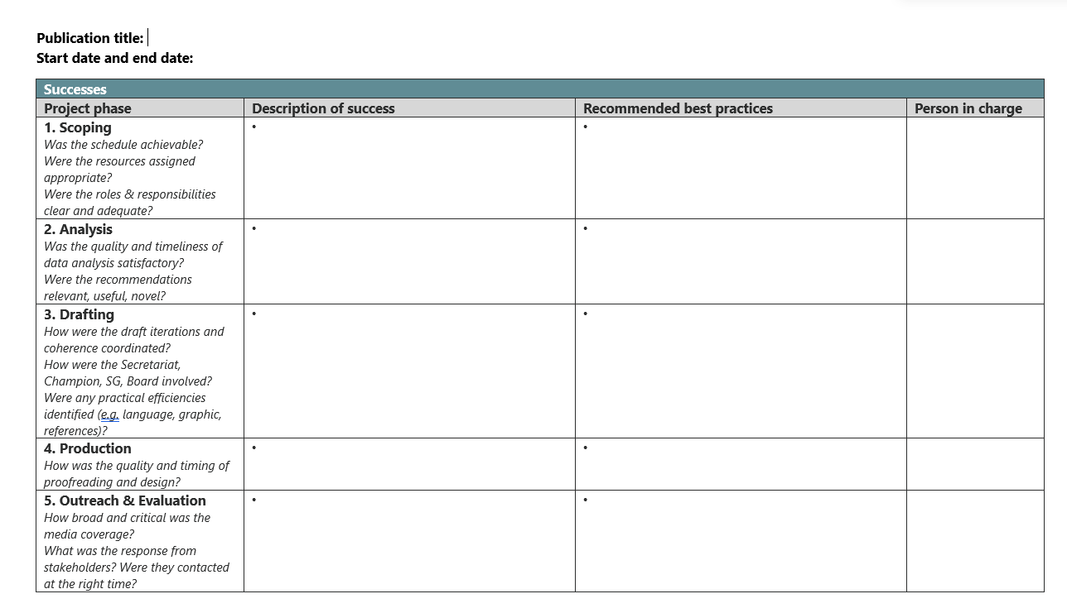
Step-by-step
1 Formulation of expectations at the kick-off meeting
The process of learning and continuous evaluation of the project already starts at the kick-off meeting. It is important that learning and experiences from previous projects are brought into play from the start of the project process.

2 Continuously evaluation in the project team
The regular project meetings are an obvious opportunity to have regular intervals of mutual feedback and evaluation of the progress so far. An open ongoing dialogue and curiosity, in relation to what each other and others outside the project experience works well and less well, makes it possible to continuously make improvements.

3 Evaluation meeting after publication
Project evaluation is the last deliverable in the project before the project can be closed. In practice, this means that the project will appear in the portfolio overview until the evaluation has been completed.
A minimum of one hour should be set aside to ensure a good rounding of the project. The meeting is facilitated by the project lead, and input can advantageously be noted continuously, e.g. with Post-its, so that it is easy to collect and document learning. It is important that the team identifies the most significant learnings and recommendations.

4 Knowledge sharing in the Secretariat
It is expected that the most important learning from the project is shared with the rest of the Secretariat, for example at a Secretariat meeting.

5 Celebrating the project
Remember to celebrate the successful completion of the project

Find the template here.

7.8 Project evaluation in the Advisory Board (Evaluation Matrix)

The Advisory Board's perspectives on the process, impact creation and desired improvements

Purpose
The purpose of the evaluation is to create a dialogue in the Advisory Board about the most important learnings in the project process seen from the Advisory Board's perspective and to conclude on the Advisory Board’s specific wishes for major and minor adjustments going forward.
The purpose is also to make evaluations an integrated part of the Advisory Board's work and to create a reflective mindset, in relation to how processes, collaboration, impact creation etc. can be improved in the Advisory Board’s work programme.

The format and focus of the evaluation
The extent of the evaluation is up to the Advisory Board – it can be based on perspectives and learning in relation to:

1) realisation of the purpose of the analysis
2) project progress
3) cooperation with the Secretariat
4) perceived quality
5) early impact creation

Based on the Advisory Board members' perspectives and input, the Advisory Board’s concrete recommendations for future project courses are identified.
The evaluation can either be carried out orally at a Board meeting and/or in writing in the form of a short questionnaire. The evaluation is mandatory, but the scope can easily be limited if there is no input from the Advisory Board.
It is the management group's responsibility to implement recommendations in the Secretariat's internal processes and Advisory Boards support afterwards.

Evaluation – When?
All projects in the Advisory Board must be evaluated by the Advisory Board. It is the project lead's assessment, in dialogue with the head of Secretariat, whether the evaluation should take place immediately after the completion of the project, or whether it makes sense to carry out the evaluations, for example, quarterly.
It is the project lead’s responsibility to clarify the time, focus and format for an evaluation in the Advisory Board. As a rule of thumb, the evaluation should not be carried out later than a maximum of 3 months after the activities in the production & outreach phase have been completed.

Step-by-step
1 Clarification of time, focus and format
The project lead clarifies with the head of Secretariat how the evaluation is carried out most appropriately. Should time be set aside at the next Advisory Board meeting for an evaluation discussion in the Advisory Board – or is it sufficient to carry out a written evaluation which is subsequently shared with the Advisory Board? Does the project process give rise to a specific emphasis on focus?

2 Preparation of the evaluation
The project team is responsible for preparing the evaluation, either in the form of facilitating an Advisory Board discussion (e.g. on the basis of reflection questions received beforehand) or preparing a short questionnaire. The scope is clarified by the project lead.

3 Implementation of the evaluation
It is agreed with the project lead who facilitates the evaluation or is the sender of a written evaluation.

4 Follow up on the evaluation
It is the head of Secretariat’s responsibility to ensure that the Advisory Boards input and conclusions are incorporated into the Secretariat's project practice, and that the Advisory Boards support for future analyses reflects the wishes and needs that emerge from the evaluation.

Find the template here.

See communication policy for the European Scientific Advisory Board on Climate Change, adopted on 29 March 2023.

